**Experient-6**

**Design and Configuration of Tree Topologies using Packet Tracer.**

**Step1:** 3 switches and 6 PCs

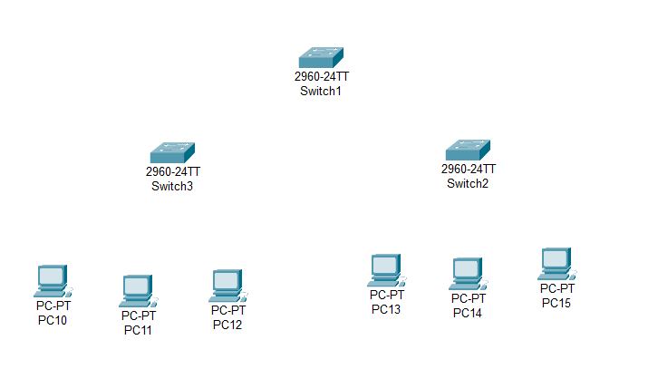

**Step2:** connect fast ethernets from switch to switch and switch to PCs

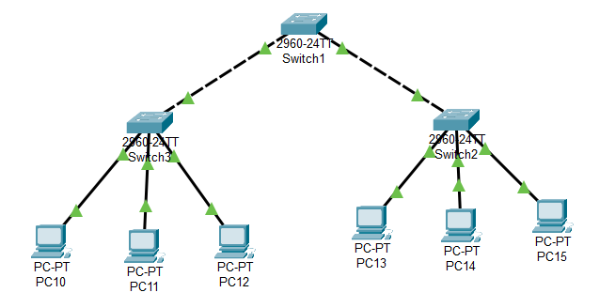

**Step3:** Assign IP address for each PCs

IP address for PC10:192.168.1.1

IP address for PC11: 192.168.1.2

IP address for PC12: 192.168.1.3

IP address for PC13: 192.168.1.4

IP address for PC14: 192.168.1.5

IP address for PC15: 192.168.1.6

**Step4:** allocate the message

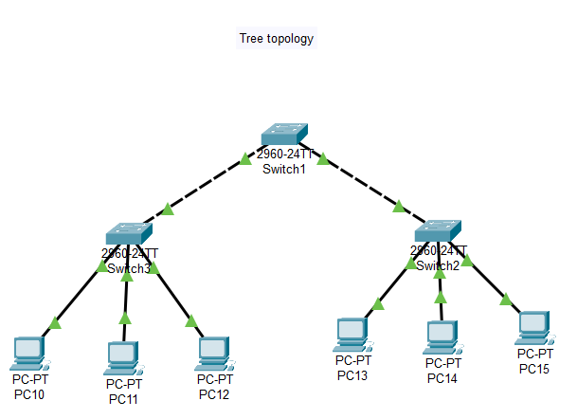

**Result:** message sent successfully from PC11-PC15